

Group Members | Mohammed Rasheed Yehia AL Haddad (Leader)(TP072509)  Mohamed Abdurrazag Jaber Seklani (TP073802)  Shady Ehab Assad Ibrahim (TP073549)  Mahmoud Samy Aly Ibrahim Shahin(TP073272)
Intake | APD1F2303CS(CYB)
Lecturer name | Mr. Shahab Alizadeh / Mr. Joshua Samual / Dr. Kamalakannan Machap, Yogeswaran Nathan, Muhamad Wafiq
Module Name | Introduction to Networking
Hand Out Date | 23 June 2023 Week 2 (3rd -7th April)
Submission date | 2 July 2023 (week 13)

Appendices - Work Breakdown Structure:
Name | Task / Description / Responsibility | Signature
Mohammed Rasheed Yehia AL Haddad (Leader) (TP07209) | I have design floor plan.  I have Logical topology design and Justification of the topology for Melacca  Also, I have done with IP subnet and scheme and Justification of the configuration techniques for Melacca switches and router and their passwords in my branch and apply DHCB for the all devices in my branch and DNS server and I connected my routers to other branches routers | 
Mohamed abdurrazag jabber seklani (TP073802) | I have design floor plan.  I have Logical topology design and Justification of the topology for Penang  Also, I have done with IP subnet and scheme and Justification of the configuration techniques for Penang switches and router and their passwords in my branch and apply DHCB for the all devices in my branch and IoT server and I connected my routers to other branches routers | 
Shady Ehab Assad Ibrahim (TP073549) | I have design floor plan.  I have Logical topology design and Justification of the topology for Ipoh  Also, I have done with IP subnet and scheme and Justification of the configuration techniques for Ipoh switches and router and their passwords in my branch and apply DHCB for the all devices in my branch and Email server and I connected my routers to other branches routers | 
Mahmoud Samy Aly Ibrahim Shahin(TP073272) | I have design floor plan.  I have Logical topology design and Justification of the topology for KL  Also, I have done with IP subnet and scheme and Justification of the configuration techniques for KL switches and router and their passwords in my branch and apply DHCB for the all devices in my branch and IoT server and I connected my routers to other branches routers | 

Table of Contents
Introduction: 3
Mahmoud Samy Aly Ibrahim Shahin (TP073272) 5
1.1 logical topology design: 5
1.1Star topology: 5
1.2 Extended Star Topology 6
1.4 Floor plan: 7
1.5 Subnet table: 8
IP address justification: 9
Mohamed Abdurrazag Jaber Seklani TP073802 (Penang Branch) 9
Logical topology design: 9
Star Topology Design: 10
Extended Star Topology Design: 10
Floor plan: 10
3.0 Justification of the topology: 12
3.1 Star topology: 12
3.2 Extended star topology: 13
4.0 IP Addressing scheme: 15
Shady Ehab Assad Ibrahim TP073549(Ipoh Branch) 17
1.0Logical topology Design for: 17
1.1Star Topology: 17
1.2 Extended Star Topology: 19
1.3 Floor Plan: 22
In MapleTech company (Ipoh Branch): 23
1.4 IP Addressing table: 24
1.5 IP justification: 24
Mohammed Rasheed Yehia AL Haddad (Leader)(TP072509) 25
Malacca Branch: 25
Star Topology: 25
Justification of the Topology: 25
Extended Star: 26
Justification of the Topology: 27
IP Address Scheme: 27
Justification of the configuration techniques: 28
Switch configuration (Vlan1): 28
Switch security (Password) 28
DNS Server: 31
DHCP Server: 33
Routing Configuration (RIP): 36
Mesh Topology: 37
Topology Justification: 37
IoT Server 39
Conclusion: 40
References: 41

Introduction:
By developing a comprehensive network plan for MapleTech's four branches. Design and implementation of a strong network infrastructure that meets the connection requirements of MapleTech's four branches—KL, IPOH, Melaka, and Penang—is our main focus. Our objective is to establish effective data transfer and seamless communication throughout the entire organization.
Private Local Area Networks (LANs) are first installed as part of our network plan at each branch location. These LANs will be built with each branch's unique needs in mind, taking into account things like user density, bandwidth constraints, and application requirements. We guarantee localized network access and enhanced performance for MapleTech's employees by building exclusive LANs for each branch.
Our network design calls for the creation of a Wide Area Network (WAN) to enable seamless communication and collaboration across the branches. In order to provide effective resource sharing and data exchange within the organization, the WAN will act as the backbone connecting all of the branch sites. We will put into place safe and quick connectivity solutions.
As all communications between branches will stay within the company's secure network environment. The WAN also makes it possible for centralized control and monitoring, streamlining network administration and enhancing troubleshooting effectiveness.

Mahmoud Samy Aly Ibrahim Shahin (TP073272)

1.1 logical topology design:
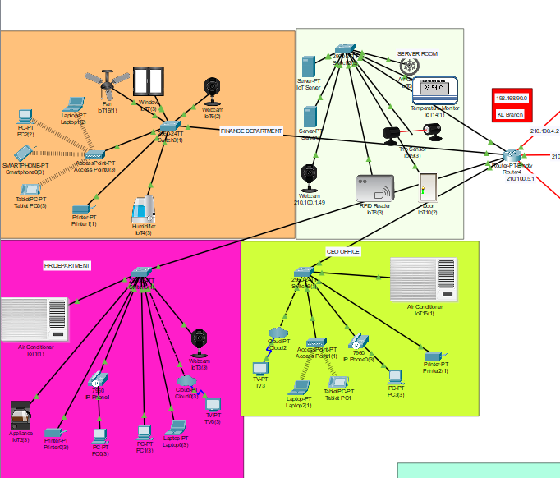
Figure1.0

1.1Star topology:
Star topology is a network configuration where all devices are connected to a central hub, forming a star-like structure. It has gained popularity due to its numerous advantages and is often a preferred choice for network implementations.
the network may be managed and controlled centrally thanks to the central hub. Due to the concentration of all connections at one location, network problems are easy to monitor and troubleshoot. The star architecture also makes network expansion simple and highly scalable. Without affecting the current network connections, new devices can be added by merely connecting them to the central hub. It is appropriate for both small and big networks because of its versatility.
Fault isolation is another perk. If one device or link breaks in a star topology, it has no impact on the operation of any other devices or the network as a whole. As long as the central hub is operating effectively, this guarantees that the network will remain functional.

1.2 Extended Star Topology
Extended star topology, also known as a hybrid star topology, is a variation of the traditional star topology that includes additional networking components to enhance network performance and flexibility. It combines the advantages of star topology with other network topologies, such as bus or ring, to meet specific networking requirements.
Here is some advantages:
Scalability: The network may be easily expanded to handle increasing needs and the inclusion of more devices thanks to the extended star topology.
Fault Tolerance: High network dependability is achieved by ensuring that if a device or link malfunctions in one star segment, it has no effect on the connectivity of the entire network.
Effective Bandwidth Management: Network traffic can be dispersed among the network's numerous star segments, easing congestion and enhancing overall performance.

1.4 Floor plan:

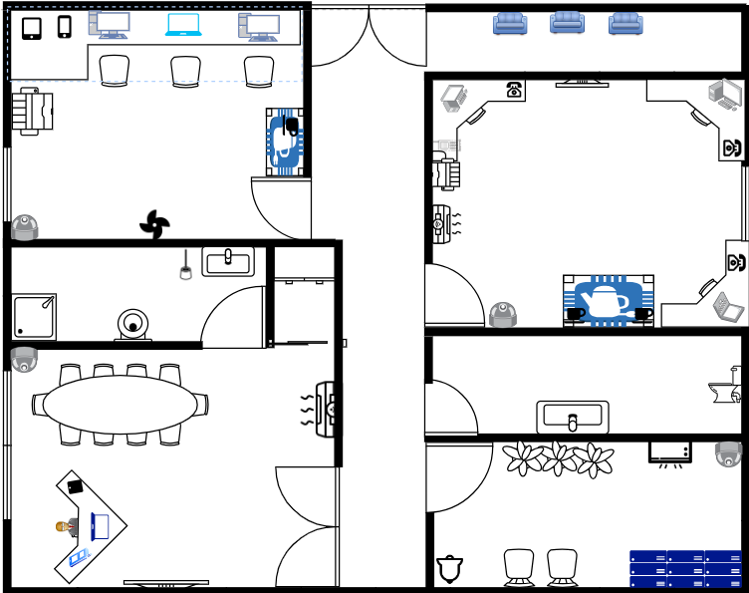
Figure1.2
The company's floor concept makes use of IoT gadgets like cameras, a/c units, laptops, tablets, smartphones, and PCs. These gadgets promote productivity and connectivity while enhancing security and working circumstances. The arrangement comprises workstations outfitted with a variety of gadgets for smooth connection and access to data, strategically placed cameras for real-time tracking, and IoT-enabled air conditioning systems for comfort control. To design a contemporary and effective workspace, the floor plan also takes into account cable management, power outlets, and comfortable workstations.

Subnet table:
Subnet | Block Size (Host - 0) | Subnet Mask / Prefix Length | Network Address | Default Gateway | Range of Usable IP | Broadcast Address
Finance Department | 80 | 255.255.255.128\25 | 192.168.90.0 | 192.168.90.1 | 192.168.90.2-192.168.90.126 | 192.168.90.127
HR Department | 50 | 255.255.255.192\26 | 192.168.90.128 | 192.168.90.129 | 192.168.90.130-192.168.90.190 | 192.168.90.191
Server room | 25 | 255.255.255.224\27 | 192.168.90.192 | 192.168.90.193 | 192.168.90.194-192.168.90.222 | 192.168.90.223
CEO ROOM | 12 | 255.255.255.240\28 | 192.168.90.224 | 192.168.90.225 | 192.168.90.226-192.168.90.238 | 192.168.90.239

IP address justification:
Since it is contained within the private IP address range, the 192.168.90.0 subnet is appropriate for use internally within the company. Because private IP addresses cannot be routed over the public internet, internal network isolation and security are guaranteed. Also the IP address is type C for the small company and its uses.

Mohamed Abdurrazag Jaber Seklani TP073802 (Penang Branch)

Logical topology design:

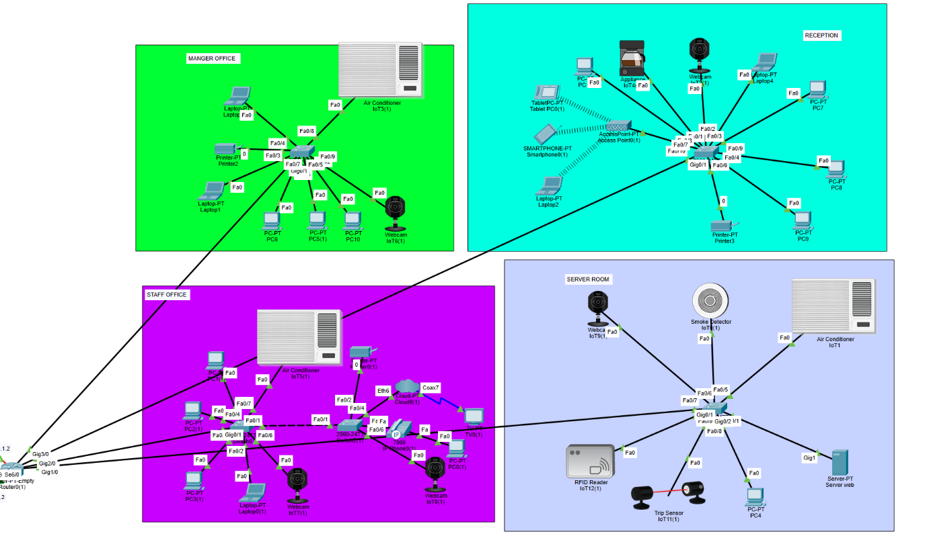
Figure 1.3

Star Topology Design:
Our network uses a star topology where every node connects directly to a central hub or switches through a point-to-point link. The main hub serves as the server, while the peripherals act as the clients. Data transfer is controlled and managed by the hub or switch to prevent packet collision. This setup ensures that each device has a dedicated link to the hub, reducing the likelihood of data packet collisions. Also, fault detection and isolation are simplified since each device is connected separately.

Extended Star Topology Design:
Our network uses a combination of star and extended star topologies for efficient networking. Extended star topology connects additional switches to the central hub, forming multiple star topologies and allowing for scalability. This topology isolates network issues and simplifies management. Overall, it's an efficient choice for our networking needs.

Floor plan:

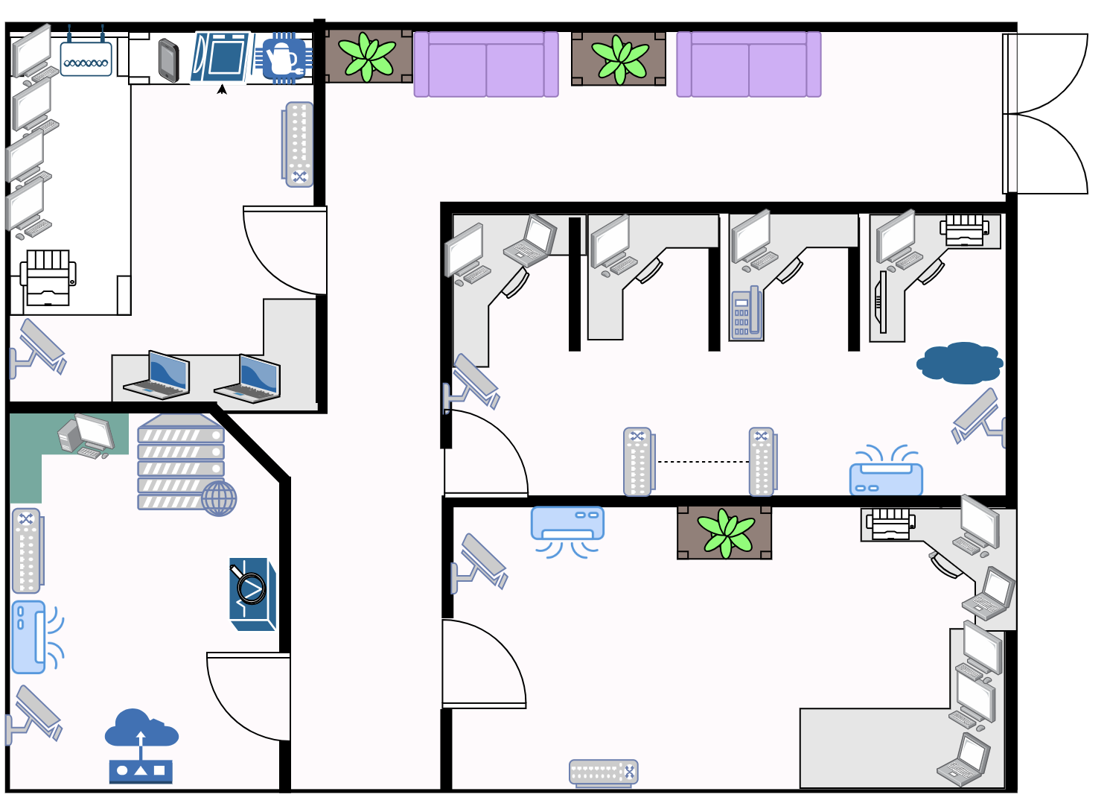
Figure 1.4

The floor plan above displays the layout of each office in the Penang branch. Starting with the RECEPTION area located in the north-west corner of the department, it includes various equipment such as a printer, four computers, laptop, and one webcam IoT, as well as a coffee maker all of these are connected to the switch LAN. Additionally, there is an Access Point that connects to a tablet, smartphone, and one laptop wirelessly. The STAFF office in the north-east corner of the branch has a variety of equipment. It includes four computers, a printer, a laptop, and two IoT webcams. Additionally, there is cloud, a TV, an IP telephone, two switches, and an air conditioner. The MANEGER room in the south-east of the branch is equipped with three computers, two laptops, a printer, a webcam, air conditioner, and a switch. The final office in the branch is the Server room, which is situated in the south-west corner. It contains a computer, a web server, a smoke detector to prevent fires, an intrusion sensor to prevent unauthorized access, and an air conditioner.

3.0 Justification of the topology:

3.1 Star topology:

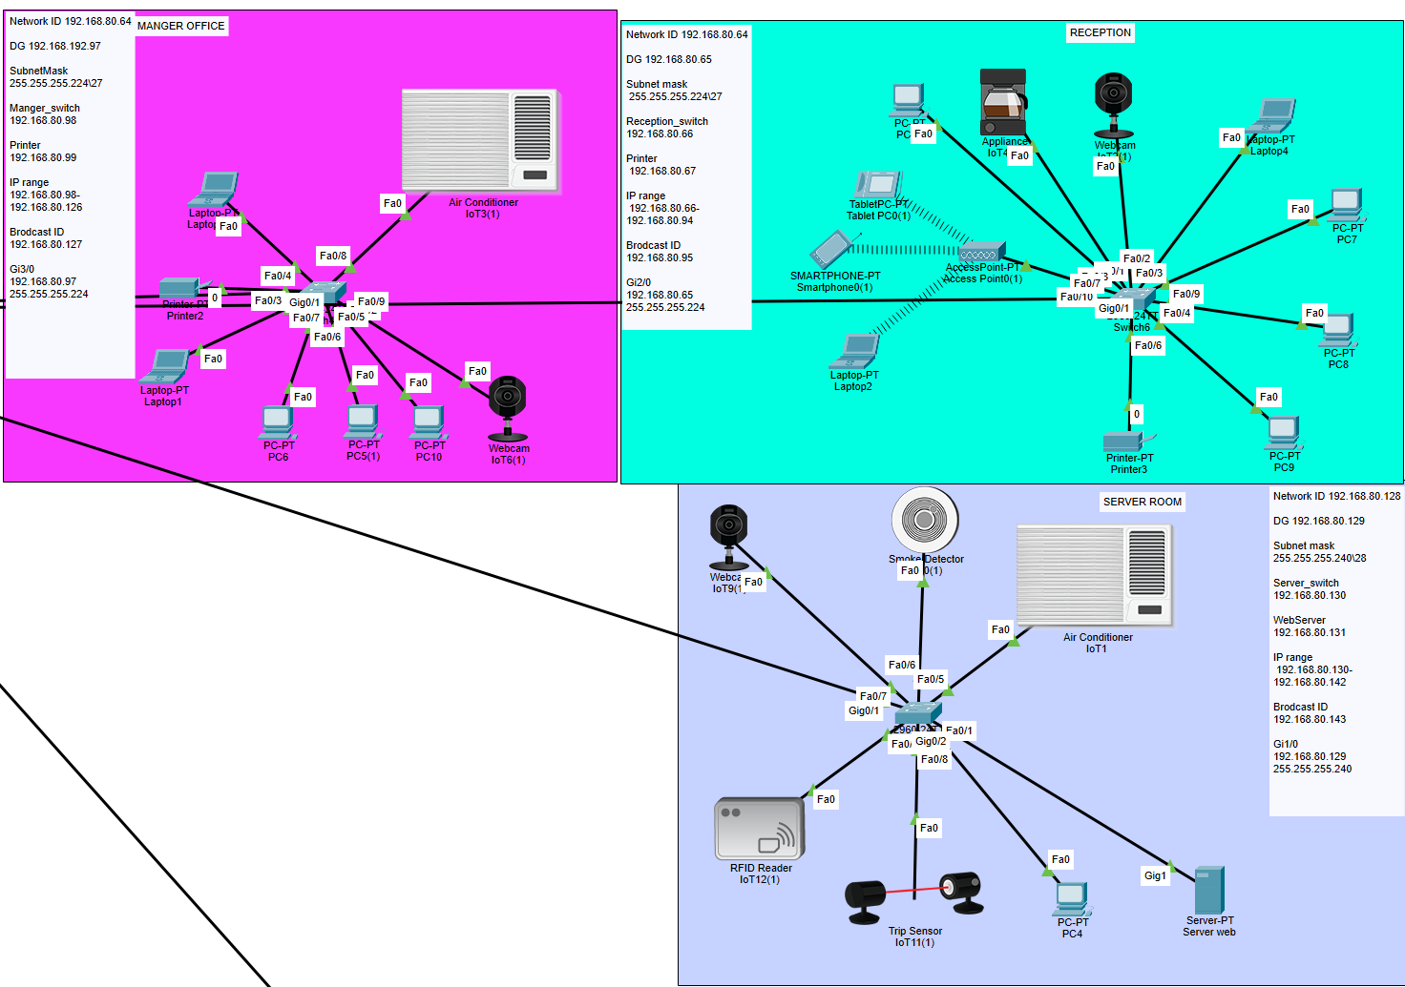
Figure 1.5

The star topology was chosen because it is simple and easy to manage. This setup enables users to easily add or remove devices without affecting the entire network, as each device connects directly to a central hub or switch.
In a star topology, if a single node fails, it will not have any impact on the other nodes within the network., making it more reliable. Troubleshooting the network is also easier because you can quickly isolate issues with individual devices, resulting in less downtime.
In addition, the star topology provides superior performance when compared to other topologies such as bus or ring. This is because data packets do not need to pass through numerous nodes before arriving at their destination, lowering the likelihood of data collision, and increasing the network's overall speed.

3.2 Extended star topology:

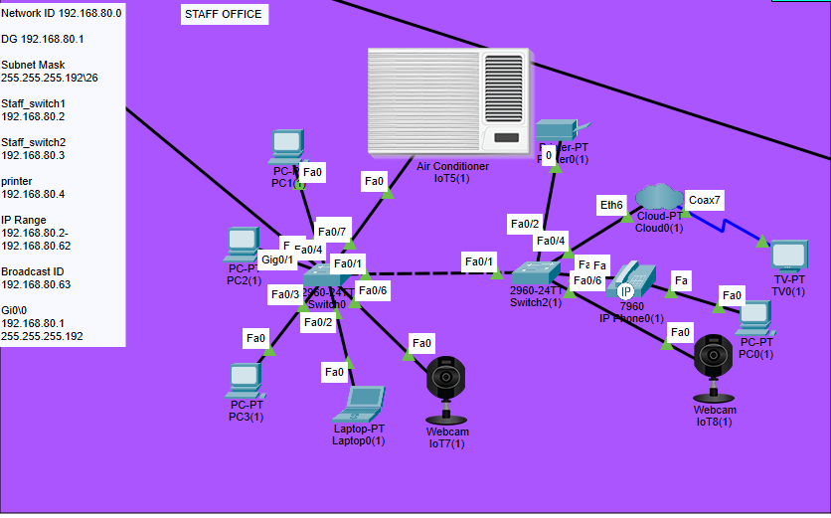
Figure 1.6

I have implemented an extended star topology in certain areas of our network to improve its scalability and reach, which is essential for our growing organization. This topology makes it easy for us to add more devices to the network by adding additional switches to the central hub, allowing for flexible network expansion.
The extended star topology also increases fault tolerance. If one of the star networks fails, the problem is limited to that specific network, minimizing disruption to the overall network. This ensures high availability and resilience, which are critical for maintaining the continuous operation of our network.
In summary, I chose a star and extended star topology combination for its ease of network management, scalability, resilience, and superior performance. These design choices ensure that our network is robust, efficient, and flexible enough to accommodate future growth and expansion.

4.0 IP Addressing scheme:

Room | Block Size (Host - 0) | Subnet Mask / Prefix Length | Network Address | Default Gateway | Range of Usable IP | Broadcast Address
STAFF OFFICE | 45 | 255.255.255.192\26 | 192.168.80.0 | 192.168.80.1 | 192.168.80.2-192.168.80.62 | 192.168.80.63
RECEPTION | 26 | 255.255.255.224\27 | 192.168.80.64 | 192.168.80.65 | 192.168.80.66-192.168.80.94 | 192.168.80.95
MANEGER | 20 | 255.255.255.224\27 | 192.168.80.96 | 192.168.80.97 | 192.168.80.98-192.168.80.126 | 192.168.80.127
SERVER ROOM | 11 | 255.255.255.240\28 | 192.168.80.128 | 192.168.80.129 | 192.168.80.130-192.168.80.142 | 192.168.80.143

IP justification, the 192.168.80.0 subnet is suitable for internal use within the organization because it falls within the private IP address range. Private IP addresses are not routable over the public internet, ensuring the internal network security and isolation. In addition, The IP address is type C has been used for the small organization.

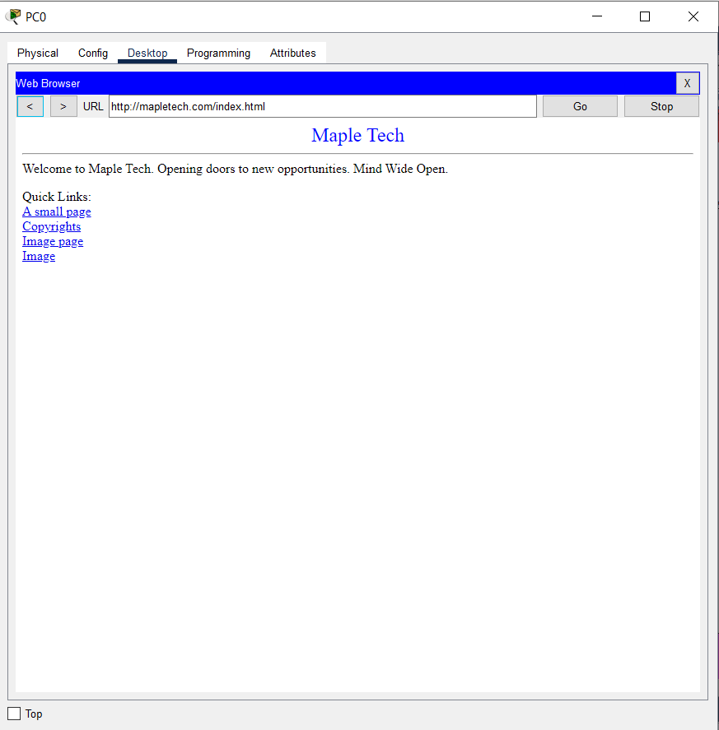
Figure 1.7

Lastly, with our current setup, the user can now conveniently search webpages from any connected PC. By inputting the Server IP or searching for MeapleTech.com by helping DNS server, you will only be shown existing the company website. To do this, simply go to any PC, open the desktop, launch your web browser, input the server IP address (192.168.80.131), and then click enter. The results will be displayed.

Shady Ehab Assad Ibrahim TP073549(Ipoh Branch)

1.0Logical topology Design for:
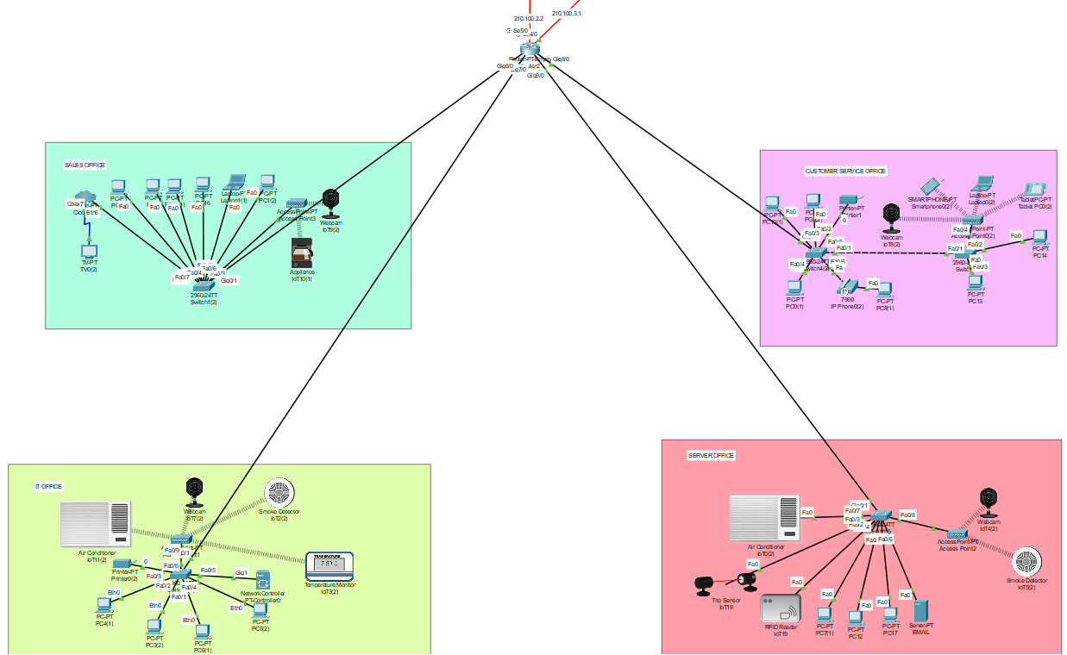
Figure 1.8

1.1Star Topology: A star topology is a network architecture in which each device in the network is linked to a central node known as the switch or hub. This topology resembles a star when shown visually.

There are some advantages and disadvantages in Star Topology.

Advantages:
- Because each device is separated from the others by how it interacts with the switch, the effect of a single point of failure is reduced.
- Network interruption is avoided when adding or deleting devices from the network.
- High performance since data collisions are impossible.
- Each device only requires one port to connect to the switch.

Disadvantages:

- The switch affects performance.
- The switch requires more resources and maintenance.
- All linked devices are deactivated if the switch breaks.
- requires more wiring and is more costly than other options.

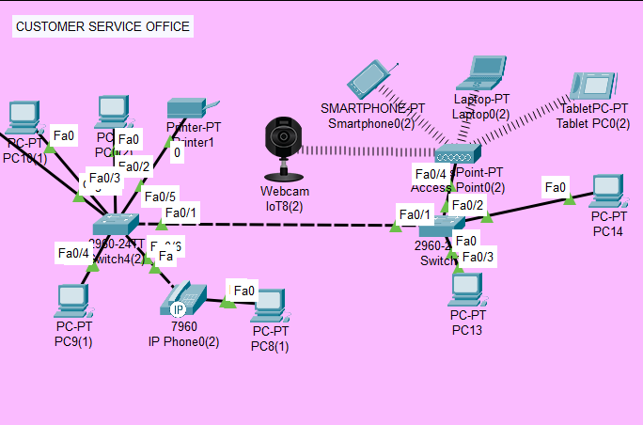
Figure 1.9
1.2 Extended Star Topology: Extended Star Topology is a network topology that is an extension of the traditional Star Topology. In this design, a hub or switch is used to join several Star networks together to create a larger network. It is frequently used in bigger network settings.
There are some advantages and disadvantages in Extended Star Topology.
Advantages:
- the performance is better in extended star topology. since the network does not transmit messages that are not necessary. Only the source node, the hub, and the destination node are involved in the message transfer.
- It can be updated to move more quickly.
- Issues with cables and devices are simple to locate.
- Failure of one node does not bring down the entire network.

Disadvantages:

- Because every node is connected to the central hub, more cable is needed than in ring network because doing so raises setup costs.
- Since every node is connected to the central hub, the failure of the central hub will result in the failure of the entire network and bring the entire network to a stop.
- An increase in the number of linked nodes will result in network congestion and a decrease in the performance of the central hub or switch.
- comparatively more expensive (in terms of installation and equipment) than bus networks.
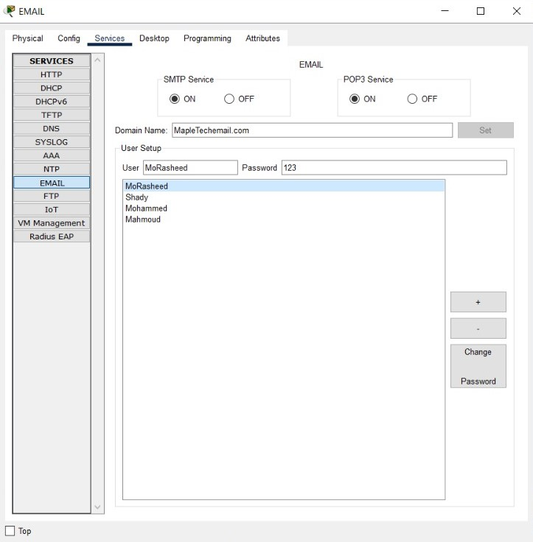Figure 2.0

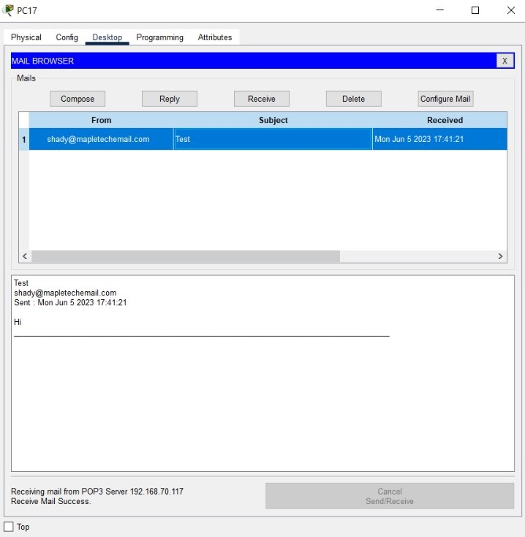Figure 2.1
There are various stages involved in configuring an email server in Cisco Packet Tracer to ensure optimum functioning and communication. Create the network topology first, then position the email server, routers, switches, and client devices as necessary. After that, set up the email server by giving it a gateway, IP address, subnet mask, and DNS server. Install and set up the email server application. Next, establish the required IP address and routing protocols on the router to allow internet access for the email server. Create the necessary MX records in the DNS server or DNS settings on an existing server to send email traffic to the server's IP address. Configure client devices, email client software, and test settings by sending and receiving emails to complete the setup.

1.3 Floor Plan:

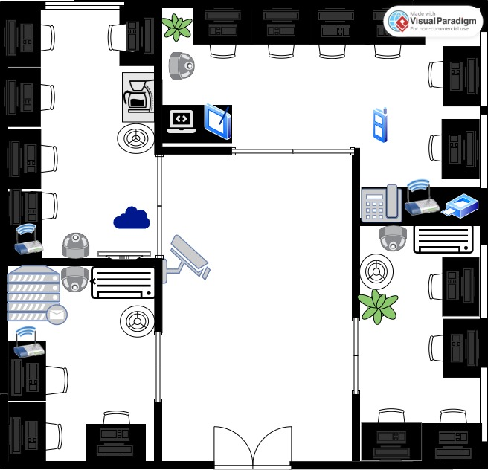
Figure2.2

In MapleTech company (Ipoh Branch):

There is:
  - 4 Webcam: to monitor the employees.
  - 3 Access point: to connect wireless to some devices.
  - 3 smoke Detector: to detect any smoke.
  - 1 RFID Reader: some of stuff only can access the server room.
  - 1 Trip sensor: so, it can identify any unauthorized guests.
  - 1 coffee machine.
  - 2 AC.
  - 1 Email server.
  - 1 tablet.
  - 1 printer.
  - 1 Cloud.

1.4 IP Addressing table:

Room | Block Size (Host - 0) | Subnet Mask / Prefix Length | Network Address | Default Gateway | Range of Usable IP | Broadcast Address
CUSTOMER SERVICE OFFICE | 50 | 255.255.255.192\26 | 192.168.70.0 | 192.168.70.1 | 192.168.70.2-192.168.70.62 | 192.168.70.63
SALES OFFICE | 24 | 255.255.255.224\27 | 192.168.70.64 | 192.168.70.65 | 192.168.70.66-192.168.70.94 | 192.168.70.95
IT OFFICE | 11 | 255.255.255.240\28 | 192.168.70.96 | 192.168.70.97 | 192.168.70.98-192.168.70.126 | 192.168.70.113
SERVER OFFICE | 10 | 255.255.255.240\28 | 192.168.70.114 | 192.168.70.115 | 192.168.70.116-192.168.70.128 | 192.168.70.129

1.5 IP justification:
The 192.168.X.0 subnet was chosen because it works well with the organization's current network infrastructure. This enables easy integration with the existing network architecture, routing protocols, and network management systems. It also reduces disruption and promotes efficient network operations.

‌

Mohammed Rasheed Yehia AL Haddad (Leader)(TP072509)

Malacca Branch:
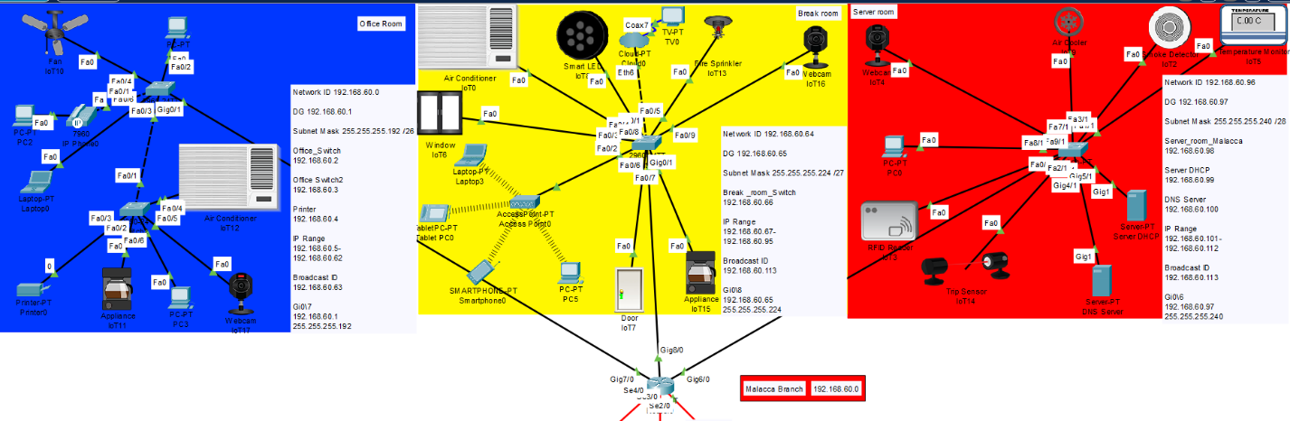
Figure2.3

Star Topology:
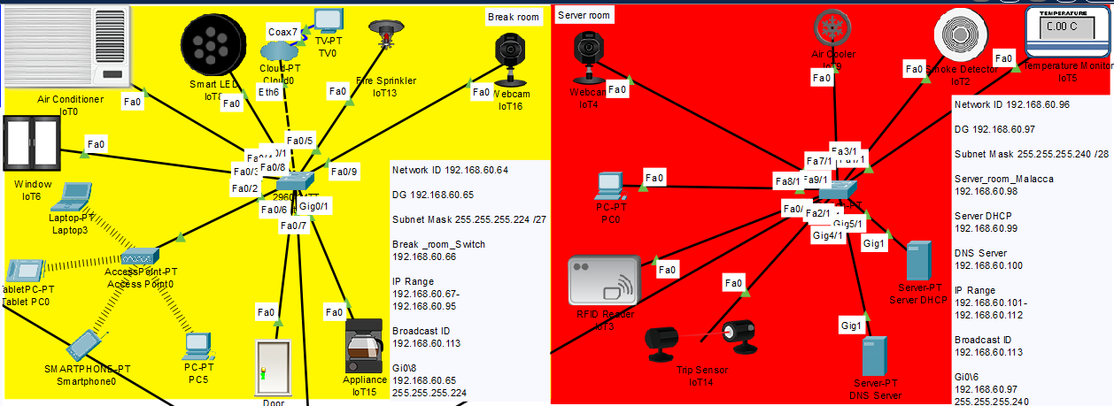
Figure2.4

Justification of the Topology:
Star topology was chosen for simplicity of setting up the network and maintaining it because it is simple to debug and locate issues because all the nodes are linked to a single hub which enables a simple server management. In addition, using a star topology for IoT devices can be linked to a central hub which makes it possible to manage the devices and get their data. Furthermore, the topology has high degree of fault tolerance, if one node fails, the other nodes won’t be harmed and this is because the main hub may keep sending traffic to the other nodes. Also, a scalable network topology is the star topology. This indicates that adding new nodes is a simple process that can be expanded for the growing company like MapleTech. However, in a star topology, the central hub serves as a single point of failure. This implies that the network as a whole will be unavailable if the central hub fails and cost more money and this is due to the central hub's higher hardware and software requirements compared to other hub types. (Prasanna, 2023)

Extended Star:
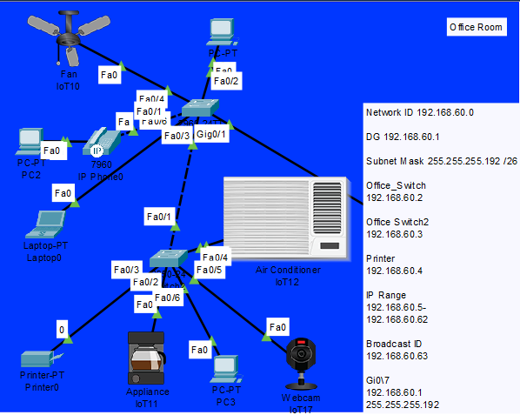
Figure2.5

Justification of the Topology:
Offices frequently employ extended star topologies because they have a lot of benefits, such as
ease of management of the network which make it simple to manage because all nodes are linked to a single hub or switch. If a node malfunctions, it is simple to isolate it from the rest of the network and repair it. Scalability of the topology allows adding more hubs or switches makes it simple to scale up extended star topologies. They are therefore perfect for expanding businesses. Moreover, extended star topologies are relatively dependable because just one node can fail without the network going down as a whole. Lastly, using extended star topology allow the computer to access the same files and applications of the file server and printer to print server that would allow all the employees to print the same printers and security cameras to a central recording system that helps the security team to detect the entire office from a single location. Nevertheless, an increase in the number of connected nodes will result in network congestion and lower performance from the central hub or switch. (Extended Star Topology | Importance and Uses of Extended Star Topology, 2020)

Floor Plan
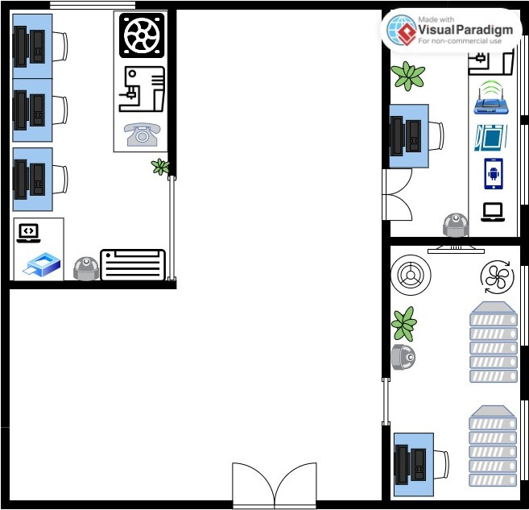

IP Address Scheme:
Room | Block Size (Host - 0) | Subnet Mask / Prefix Length | Network Address | Default Gateway | Range of Usable IP | Broadcast Address
Office Room | 45 | 255.255.255.192\26 | 192.168.60.0 | 192.168.60.1 | 192.168.60.2-192.168.60.62 | 192.168.60.63
Break room | 26 | 255.255.255.224\28 | 192.168.60.64 | 192.168.60.65 | 192.168.60.66-192.168.60.94 | 192.168.60.95
Server room | 11 | 255.255.255.240\28 | 192.168.60.96 | 192.168.60.97 | 192.168.60.98-192.168.60.110 | 192.168.60.111

IP Address Justification:
Because it is part of the private IP address range, the 192.168.60.0 subnet is appropriate for internal use within the company. Internal network security and isolation are guaranteed since private IP addresses cannot be routed through a public internet connection. Additionally, the little organisation has been using an IP address of type C.

Justification of the configuration techniques:

Switch configuration (Vlan1):
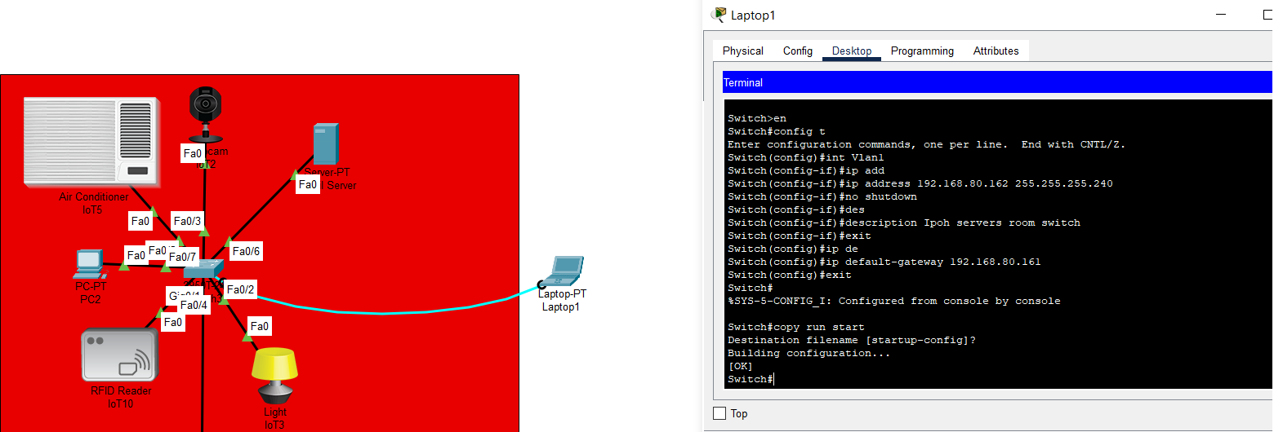
Figure : Switch configuration using console
In figure , the laptop is connected with the switch using console cable and then going to the terminal of the laptop will allow us to enter the CLI (command-line interface) of the switch. Giving the laptop commands by enabling the switch then configure terminal to enter the command, navigate to "enable" > "config t" > “interface Vlan1” , put the ip address with the subnet mask with no shutdown and description, exit and put the default gateway, exit and save by “copy run start”.

Switch security (Password)
configuring all the switches in all branches that in the company, including applying IP addresses, console passwords, privilege mode, and encryption for all passwords. This ensures greater security and makes it more difficult to penetrate. Additionally, I have created a banner and will provide more details below.

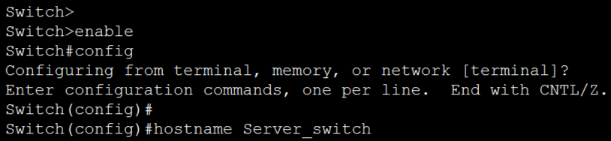
Figure 2.6
The figure above illustrates the process of changing the HOSTNAME. To do this, simply navigate to "enable" and then enter "config t" followed by "hostname" and the desired name.

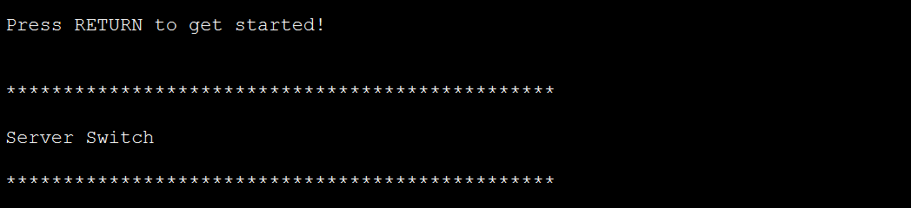Figure 2.7
Firstly, it will show the banner message to anyone who accesses the switch. To clarify how I have made the banner.

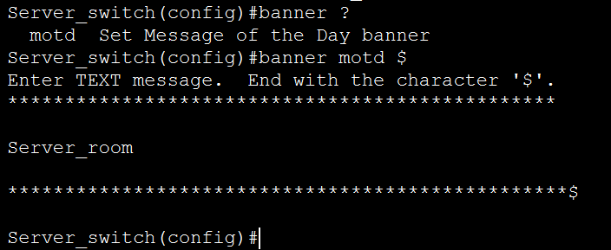
Figure 2.8
You can use the $ symbol as a start and stop character for the MOTD banner. However, if you prefer, you may use another character. This is what the MOTD banner looks like A nice and welcoming banner that everyone will see.

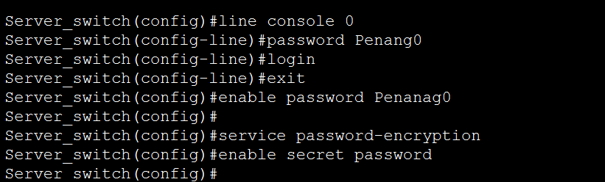
Figure 2.9
It is crucial to prioritize network protection by creating encrypted passwords for both the console and privilege mode. The figure above demonstrates how passwords have been applied and encrypted, and a secret password has been created for privilege access.
Switches Passwords:
- Penang switches password
Console Penang0
EN pass Penang1
- Melaka switches password
Console pass Melaka10
En pass Melaka9
- Kl switches password
Console pass kuala10
En pass kuala9
- Ipoh switches password
Console pass ipoh10
En pass ipoh9

DNS Server:
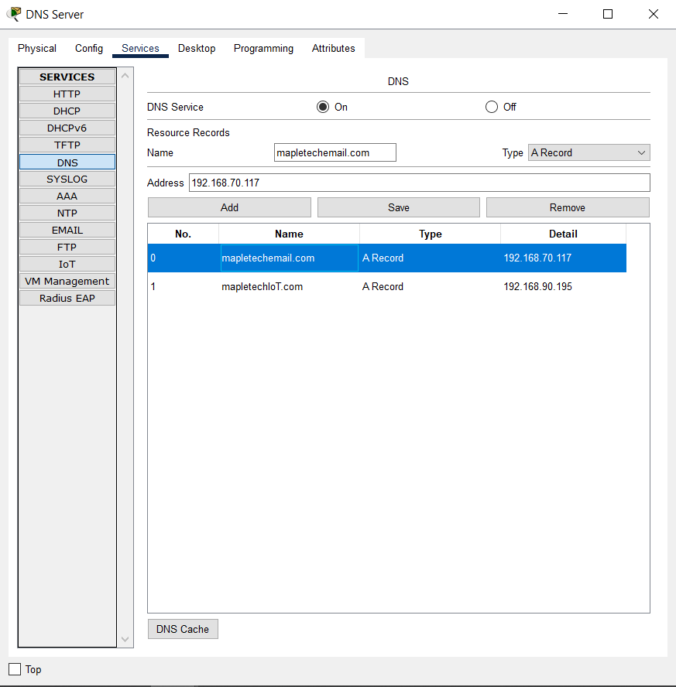
Figure3:DNS Server
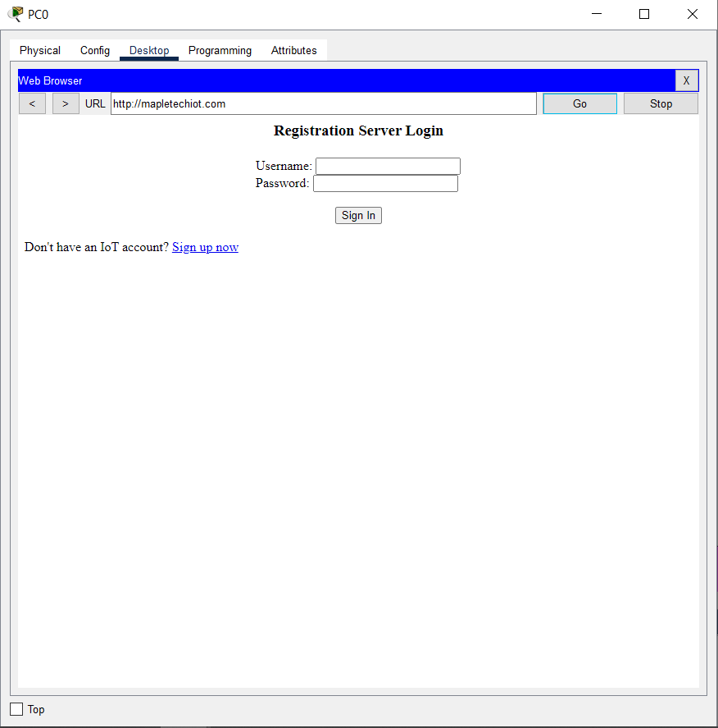
Figure3.1 : MapleTech IoT website

With the help of DNS server, no need to remember the IP address of the website instead you can write the name of the website and it opens for you the web page by typing the website name of the IP address.

DHCP Server:
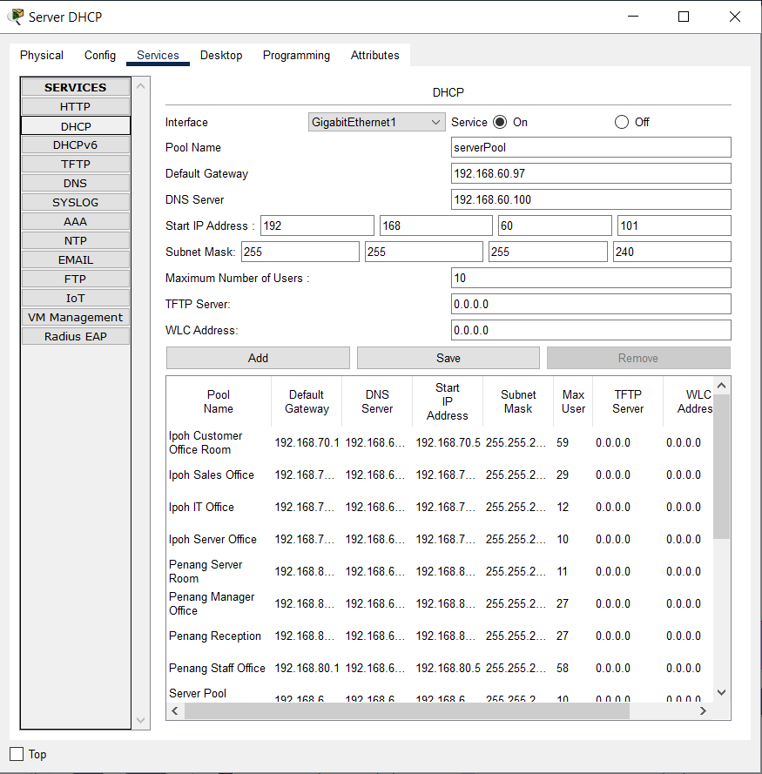
Figure3.3 : DHCP Server
By providing 1 DHCP server to all the branches, we put the default gateway, DNS server, start IP address and subnet mask for each room by the help of the IP address scheme of each branches.
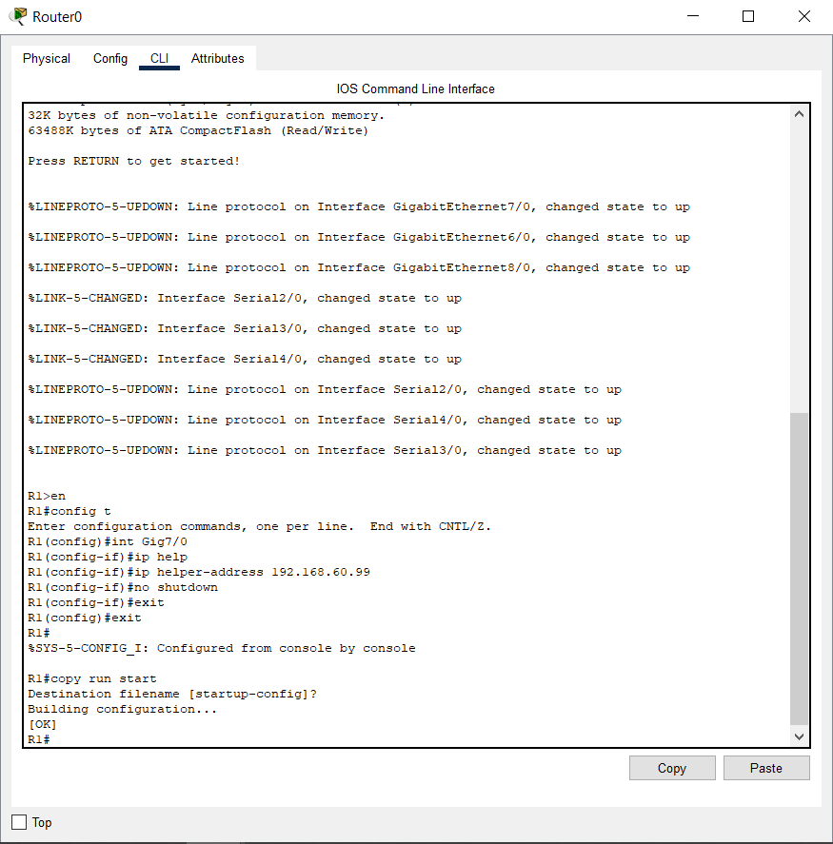
Figure3.4 :IP helper-address
We enter the router CLI and input “enable” > “configure terminal” > interface of the cable that is connected with > and input the IP helper-address which is the static IP address of the DHCP server with no shutdown and that applies to each router.

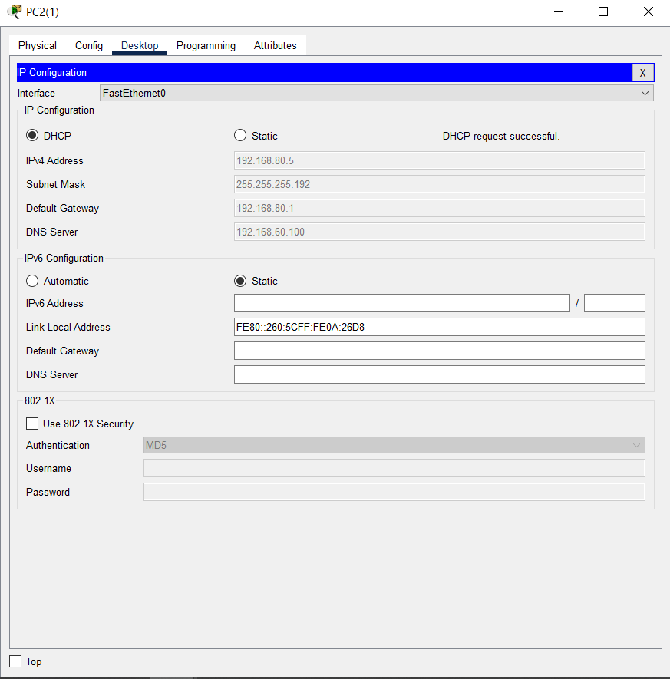
Figure3.5 : Successful DHCP IP request
By pressing the DHCP, the IP address configuration will be automatic and give its IP address as planned.

Routing Configuration (RIP):
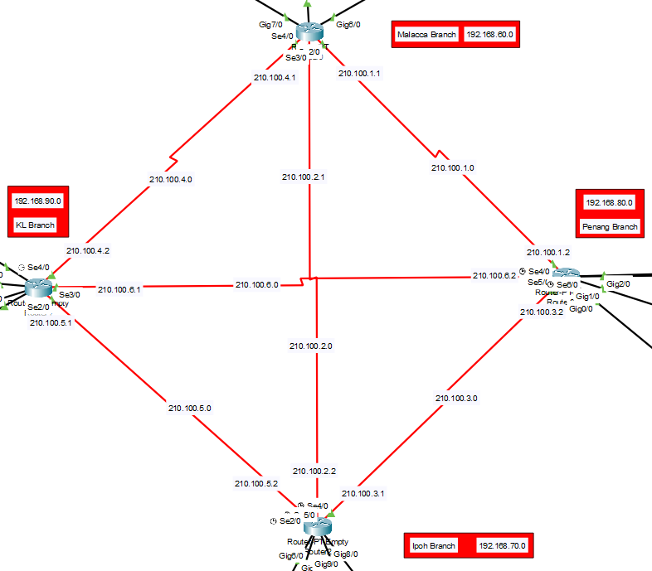
Figure3.6 : Routers connected with each other
As shown in figure , router connected each serial DCE cable with each router and every router with its serial IP address and network ID.

Mesh Topology:
Mesh routing is a method of routing data in a fully interconnected network, where each node has a direct connection to every other node. It uses algorithms to determine the best paths for data transmission. Mesh networks provide redundancy, fault tolerance, and self-healing capabilities.

Topology Justification:
The mesh topology refers to a network configuration in which every computer and network device are interconnected with each other. The implemented topology configuration facilitates the distribution of the majority of transmissions, even in the event of a single connection failure. The topology in question is frequently employed in wireless network configurations. Presented below is a visual representation illustrating a rudimentary computer configuration within a network infrastructure employing a mesh topology.

There are two types of Mesh topologies:
1 - Fully connected Mesh Topology
2 - Partially connected Mesh Topology

Full mesh topology provides redundancy but is expensive and reserved for network backbones. It requires n(n-1) connections, while partial mesh is more practical and works with a full-mesh backbone in peripheral networks. Both topologies offer redundancy and cost-effectiveness.
Mesh topology in network infrastructure offers advantages like handling traffic volumes, robustness, and supplementary device inclusion without disruption. However, it has higher implementation costs and requires significant time and effort investment. (Mesh, 2018)

Mesh. (2018). What is Mesh Topology? Computerhope.com. https://www.computerhope.com/jargon/m/mesh.htm
‌

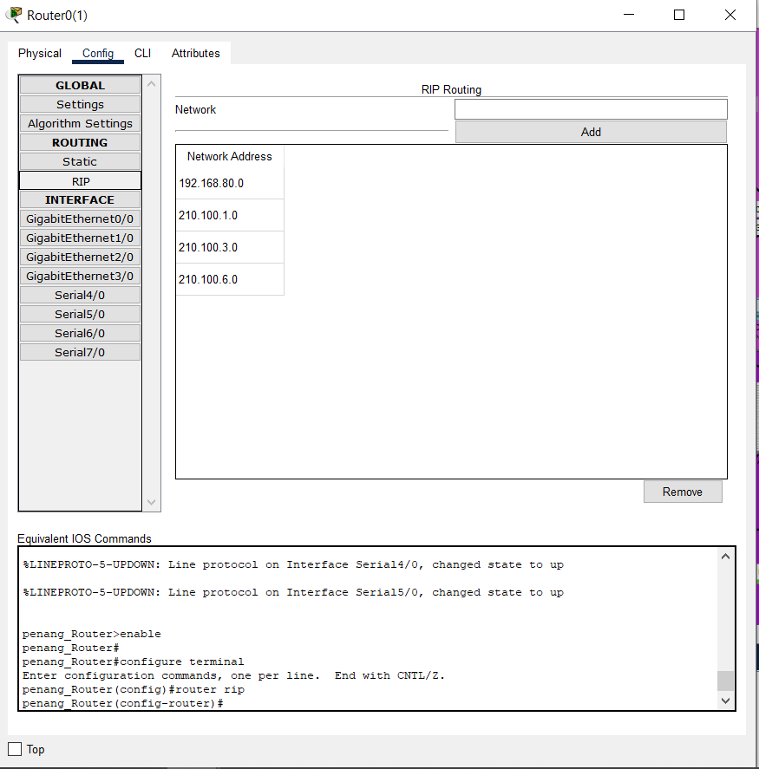
Figure3.7 : RIP
The configuration that have been used as figure shows is RIP by giving to the router the network address that it is connected with and it will find the best path between the source and the destination network automatically.

IP Routing Scheme
IP addressing Scheme from KL to:
Branches | IP Address
Melacca Branch | 210.100.4.2
Penang Branch | 210.100.6.1
Ipoh Branch | 215.123.5.1

IP addressing Scheme from Melacca to:
Branches | IP Address
KL Branch | 210.100.4.1
Penang Branch | 210.100.1.1
Ipoh Branch | 210.100.2.1

IP addressing Scheme from Ipoh to:
Branches | IP Address
Melacca Branch | 210.100.2.2
Penang Branch | 210.100.3.1
KL Branch | 210.100.5.2

IP addressing Scheme from Penang to:
Branches | IP Address
Melacca Branch | 210.100.1.2
KL Branch | 210.100.6.2
Ipoh Branch | 210.100.3.2

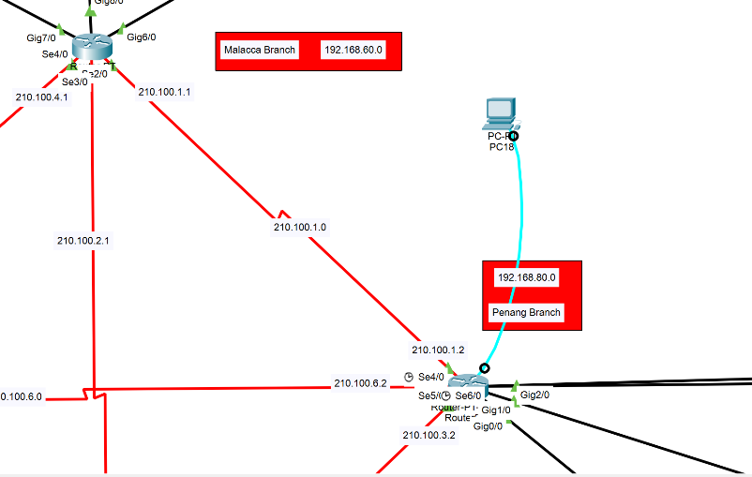

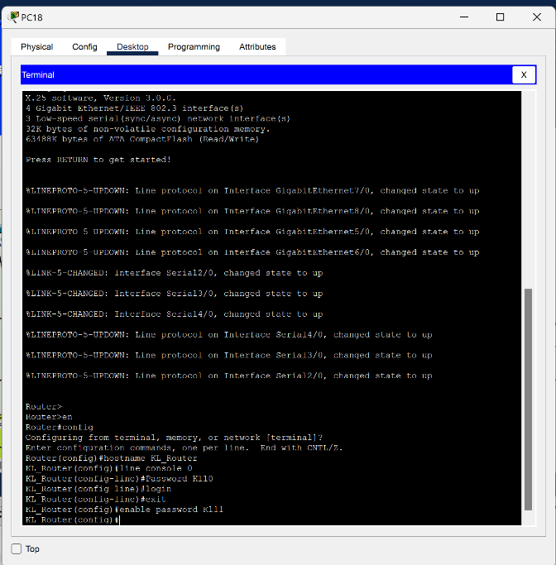
Figure3.8
I have configured all the routers on the company network. I changed their hostnames to names like "Penang_Router" and applied passwords for both console mode and privilege mode. These are the passwords that are used across all branches:
- Penang router password: Penang10 enable password Penang11.
- Melaka router password Melaka10 enable password Melaka11.
- Kl router password Kl10 enable password Kl11.
- Ipoh router password Ipoh10 enable password Ipoh11.

IoT Server
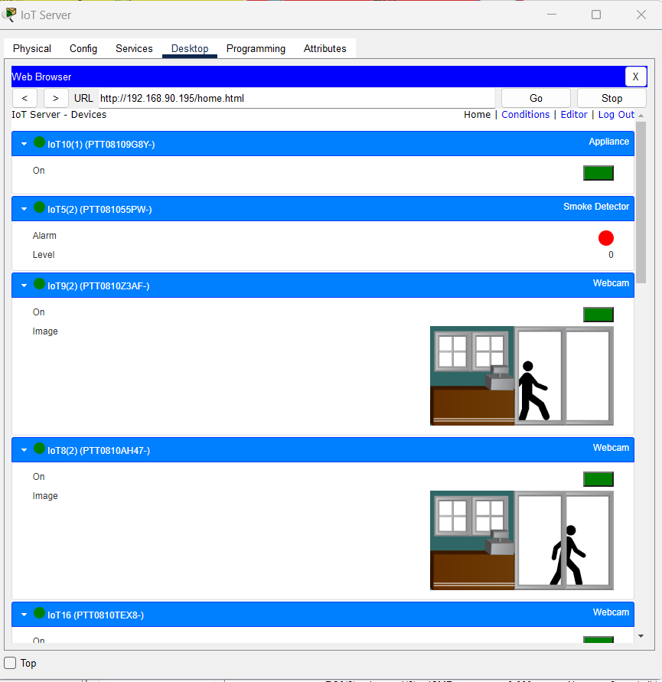
Figure3.9: IoT Server

Adding IoT devices to an IoT server brings benefits such as centralized data collection, enhanced monitoring and control, data processing and analysis, automation and integration, improved security, and privacy, as well as scalability and flexibility. It enables businesses to efficiently manage and control their IoT devices, gather valuable insights from data, automate processes, ensure security, and adapt to changing needs.

Conclusion:
In conclusion, the successful completion of this networking assignment has resulted in establishing a robust and efficient network for our company. Through careful planning and consideration of various factors, we designed a floor plan and implemented a logical topology using a combination of star and extended star topology. This design allows for scalability, reliability, and ease of management.
Furthermore, we have configured all the devices, including switches and routers, ensuring smooth communication and seamless connectivity throughout the network. The assignment also involved the implementation of various servers, such as DHCP, DNS, mail, web, and IoT servers, to cater to the diverse needs of our company.
By incorporating these essential services, we have enhanced network functionality, enabling efficient allocation of IP addresses, seamless name resolution, email communication, web hosting, and integration of IoT devices.
Completing this assignment has provided us with a solid foundation for our company's network infrastructure and equipped us with valuable knowledge and skills in network design and configuration. This experience will undoubtedly prove beneficial as we continue to grow and adapt to evolving technological advancements.
Overall, the successful implementation of the floor plan, logical topology design, and configuration of various servers and devices have resulted in a well-structured and reliable network that meets the requirements of our company. This assignment has allowed us to gain practical experience and insights into networking, empowering us to tackle future challenges and advancements in the field.

References:

Techopedia. (2023, June 28). What is Star Topology? - Definition from Techopedia. https://www.techopedia.com/definition/13335/star-topology#:~:text=28%20June%2C%202023-,What%20Does%20Star%20Topology%20Mean%3F,connecting%20nodes%20act%20like%20clients.
Bhardwaj, R. (2021, December 17). Extended star network topology " network interview. Network Interview. https://networkinterview.com/extended-star-network-topology/
Keary, T. (2023, June 22). 6 best network topologies explained - pros & cons [including diagrams]. Comparitech. https://www.comparitech.com/net-admin/network-topologies-advantages-disadvantages/
VP Online - Online Drawing Tool. (n.d.). https://online.visual-paradigm.com/app/diagrams/#diagram:proj=0&type=FloorPlan/WorkOffice&gallery=/repository/c8be14ce-aff8-4465-86af-725460ad2f9e.xml&name=Medium%20Office
1.Star Topology | Sunbird DCIM. (2021). Sunbirddcim.com.
https://www.sunbirddcim.com/glossary/star-topology
2. https://www.facebook.com/profile.php?id=100008204471322. (2021, December 17). Extended Star Network Topology» Network Interview. Network Interview. https://networkinterview.com/extended-star-network-topology/
Extended Star Topology | Importance and Uses of Extended Star Topology. (2020, February 4). EDUCBA. https://www.educba.com/extended-star-topology/
Prasanna. (2023, March 30). Star Topology Advantages and Disadvantages | What is Star Topology? Advantages and Disadvantages of Star Network Topology. A plus Topper. https://www.aplustopper.com/star-topology-advantages-and-disadvantages/
Mesh. (2018). What is Mesh Topology? Computerhope.com. https://www.computerhope.com/jargon/m/mesh.htm

